***COP2270***

***M/W***

***Spring 2017-2018***

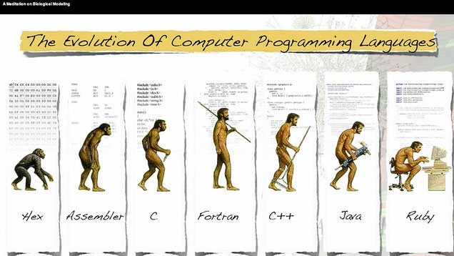

***Professor: Yassin Raef***

***Anaisy Garcia***

***Chapter 2 Homework/ Exercises***

***Duplicate Figures 2.1, 2.3, 2.4, 2.5, 2.13,***

***Problem 2-32 (BMI) + Select any programming problem from chapter 2***

***One problem per page Please***

***Figure 2-1***

|  |
| --- |
| ***Commands*** |
| ***// Fig. 2.1: fig02_01.c***  ***// A first program in C***  ***#include <stdio.h>***  ***// function main begins program execution***  ***int main(void)***  ***{***  ***printf("Welcome to C!\n");***  ***} // end function main*** |

|  |
| --- |
| ***Output*** |
|  |

***Figure 2-3***

|  |
| --- |
| ***Commands*** |
| ***// Fig. 2.3: fig02_03.c***  ***// Printing on one line with two printf statements.***  ***#include <stdio.h>***  ***// function main begins program execution***  ***int main(void)***  ***{***  ***printf("welcome ");***  ***printf("to C!\n");***  ***} // end function main*** |

|  |
| --- |
| ***Output*** |
|  |

***Figure 2-4***

|  |
| --- |
| ***Commands*** |
| ***// Fig. 2.4: fig02_04.c***  ***//Printing multiple lines with a single printf.***  ***#include <stdio.h>***  ***// function main begins program execution***  ***int main(void)***  ***{***  ***printf("Welcome\nto\nC!\n");***  ***} // end function main*** |

|  |
| --- |
| ***Output*** |
|  |

***Figure 2-5***

|  |
| --- |
| ***Commands*** |
| ***// Fig. 2.5: fig02_05.c***  ***// Addition program.***  ***#include <stdio.h>***  ***// function main begins program execution***  ***int main(void)***  ***{***  ***int integer1; // first number to be entered by user***  ***int integer2; // second number to be entered by user***  ***printf("Enter first integer\n"); // prompt***  ***scanf("%d", &integer1); // read an integer***  ***printf("Enter second integer\n"); // prompt***  ***scanf("%d", &integer2); //read an integer***  ***int sum; // variable in which sum will be stored***  ***sum = integer1 + integer2; //assign total to sum***  ***printf("Sum is %d\n", sum); // print sum***  ***} // end function main*** |

|  |
| --- |
| ***Output*** |
|  |

***Figure 2-13***

|  |
| --- |
| ***Commands*** |
| ***// Fig, 2.13: fig02_13.c***  ***// Using if statements, relational***  ***// operator, and equality operators.***  ***#include <stdio.h>***  ***// function main begins program execution***  ***int main(void)***  ***{***  ***printf("Enter two integers, and I will tell you\n");***  ***printf("the relationships they satisfy:");***  ***int num1; // first number to be read from user***  ***int num2; // second number to be read from user***  ***scanf("%d %d", &num1, &num2); // read two integers***  ***if (num1 == num2) {***  ***printf("%d is equal to %d\n", num1, num2);***  ***} // end if***  ***if (num1 != num2) {***  ***printf("%d is not equal to %d\n", num1, num2);***  ***} // end if***  ***if (num1 < num2) {***  ***printf("%d is less than %d\n", num1, num2);***  ***} // end if***  ***if (num1 > num2) {***  ***printf("%d is greater than %d\n", num1, num2);***  ***} // end if***  ***if (num1 <= num2) {***  ***printf("%d is less than or equal to %d\n", num1, num2);***  ***} //end if***  ***if (num1 >= num2) {***  ***printf("%d is greater than or equal to %d\n", num1, num2);***  ***} //end if***  ***}*** |

|  |
| --- |
| ***Output*** |
| *../../../../../../Desktop/Screenshot%202018-01-23%2021.43.* |
| *../../../../../../Desktop/Screenshot%202018-01-23%2021.44.* |
| *../../../../../../Desktop/Screenshot%202018-01-23%2021.51.* |

***Problem 2-32 (text) BMI***

|  |
| --- |
| ***Commands*** |
| ***// Problem BMI 2.13***  ***#include <stdio.h>***  ***int main(void)***  ***{***  ***int height;***  ***int weight;***  ***printf("Enter Height in Inches\n");***  ***scanf("%d", &height);***  ***printf("Enter Weight in Pounds\n");***  ***scanf("%d", &weight);***  ***int BMI;***  ***BMI = weight*703 / (height*height);***  ***printf("This BMI was calculated to be %d\n", BMI);***  ***printf("BMI VALUES from Department of Health and Human Services\n");***  ***printf("Underweight: less than 18.5\n");***  ***printf("Normal: between 18.5 and 24.9\n");***  ***printf("Overweight: between 25 and 29.9\n");***  ***printf("Obese: 30 or greater\n");***  ***}*** |

|  |
| --- |
| ***Output*** |
|  |

***Problem – 2.25 Initials***

|  |
| --- |
| ***Commands*** |
| ***// Problem Initials 2.25***  ***#include <stdio.h>***  ***int main(void)***  ***{***  ***printf("AAA\n");***  ***printf(" AAA\n");***  ***printf(" A AAA\n");***  ***printf(" A AAA\n");***  ***printf(" A AAA\n");***  ***printf(" AAA\n");***  ***printf("AAA\n");***  ***printf(" \n");***  ***printf(" GGGG\n");***  ***printf(" GGGG GGGG\n");***  ***printf("GG G\n");***  ***printf("GG GGG G\n");***  ***printf("GG G G\n");***  ***printf(" GGGGG GG\n");***  ***}*** |

|  |
| --- |
| ***Output*** |
|  |

|  |  |
| --- | --- |
| ***Command(s) learned*** | |
| ***command*** | ***comment*** |
| ***//*** | ***For writing comments - comments do not impact the program*** |
| ***# include*** | ***Look for the certain library*** |
| ***int main(void)*** | ***Start the main programming function – there could be other functions within the main function***  ***Void indicates no previous data stored – starts with blank sheet*** |
| ***{*** | ***Start the program*** |
| ***}*** | ***Program end*** |
| ***printf*** | ***Print what is in “ ” to the output*** |
| ***/n*** | ***Move to next line*** |
| ***int integer*** | ***Holds integer values in memory*** |
| ***int num*** | ***Holds number value in memory*** |
| ***scanf*** | ***Prompts you to input something*** |
| ***%d*** | ***Enter number that is an integer - numbers*** |
| ***%s*** | ***Enter words*** |
| ***int sum*** | ***Stores sum into memory*** |
| ***if*** | ***Allows program to make a decision based of truth or falsity of a condition*** |
| ***==*** | ***Equal to*** |
| ***!=*** | ***Not equal to*** |